**Data Warehouse Migration Guide**

This document details a framework for the creation of a Data Warehouse from the transactional database that is designed for this project. Although the structure of the Data Warehouse is almost entirely determined by the business questions that are of most relevance to the given business, the proposed business questions and data warehouse structure below are designed to support a wide variety of business questions without significant alteration to the structure.

Business Questions:

* How many houses were built in each year?
* How many total days were spent building houses?
* What was the total profit the sale of houses in each year?
* Which style is the most popular for each house each year?

A proposed schema is shown below:

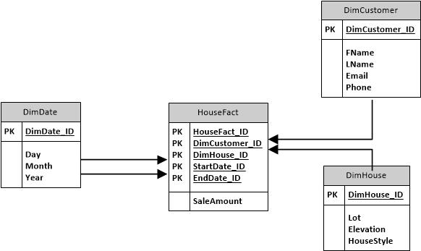

The values for the dimensional tables shown above are abridged and could be expanded to include any other relevant information to assist in answering further business questions. For example, school district and subdivision information could be included in the DimHouse dimension whereas additional demographic information could be included in the DimCustomer dimension. If business questions were developed seeking to identify information regarding the options that are selected by customers during the construction of the house, a second fact table could be added that joins the DimCustomer and DimHouse tables. Potential measures for this second fact table might include the option’s name, the stage at which it was selected, the price of the item, and the category in which it is assigned. This example is provided to illustrate that the ‘core’ star schema model provided can be expanded upon for future use.